PRE CAM TECH COURSE
IN HEALTH & SOCIAL CARE

CAM TECH SPORT COURSE OUTLINE

The course specification and units can be accessed here (OCR Specification):

This course is called the Cambridge Technical Extended certificate in Health and Social Care. It is the equivalent to 1 A level and is graded with a pass, merit, distinction or distinction* as an overall grade at the end of Year 13.

The course is split into 6 units. 3 units will be assessed with an external exam and 3 units will be assessed with coursework.

These are the units you will study over Year 12 and 13:

Year 12
Unit 1 – Building positive relationships in health and social care (external exam in January)
Unit 2 – Equality, diversity and rights in health and social care (external exam in June)
Unit 3 – Health, safety and security (external exam in January)

Year 13
Unit 4 – Anatomy and Physiology for health and social care (external exam in January)
Unit 17 – Supporting people with mental health conditions (coursework)
Unit 24 – Public Health (coursework)

SUMMER TRANSITION WORK

We are so excited to hear that you are hopefully going to be joining us in September to study Cam Tech Health and social care.
This booklet will give you a brief introduction to the course layout and help you to start getting to grips with some of the key terminology and content so that we can hit the ground running in September.

The first term there are 2 units we will study. One unit will result in an external exam in January. One unit will include completing coursework.

Please complete the 3 tasks below and bring this completed workbook with you in September. We have also added some links and information about future Career Pathways in Health and social care, with links for you to do some research!
Best wishes, Team Health and social care
*SUMMER TRANSITION WORK HAND IN WEEK: 11th – 15th SEPTEMBER

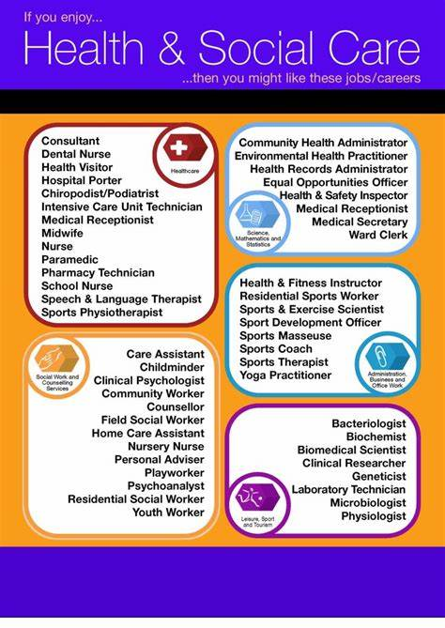

TASK 1: TYPES OF HAZARDS

Visit the following website. https://cpdonline.co.uk/knowledge-base/health-and-safety/health-safety-hazards/

Learn a definition of the 7 common types of hazards, including 3 examples of each. Write your findings up in a table with the following column headings… Type of Hazard; Definition; Examples.

TASK 2 – HAZARDS IN DIFFERENT SETTINGS
Using the same website, scroll down to the Hazards found in Hospitals, and then in Nurseries.

Make notes on how the hazards differ, or are similar, in the two different types of settings.

You may wish to create a mind map or table to demonstrate the similarities and differences.

TASK 3 – ENVIRONMENTS AND RELATIONSHIPS
In Health and social care there are 3 environments:
- Health care
- Social care
- Child care
In a mind map format write any organisation or people who are part of the environment. Eg Health care – hospital.
Create your mind maps on the next 2 pages.

HEALTH CARE

SOCIAL CARE

CHILD CARE

Choose 1 organisation and one individual from each environment and describe what they do and their role within their environment.

KEY WORDS IN CAMBRIDGE TECHNICAL HEALTH AND SOCIAL CARE
Understanding the command words for different assignments is vitally important for success. Below are a selection of keyword words that are used in assignments.

Demonstrate | Show in an explicit way (often practically demonstrate).
Describe | Give an account, including all the relevant characteristics, qualities or events.
Explain | To give account of the purposes or reasons
Outline | A description setting out main characteristics/points.
Plan | Consider, set out and communicate what is done.
Justify | Present a reasoned case for actions or decisions made.
Evaluate | Make a qualitative judgement taking into account different factors and using different knowledge/experience/evidence.
Compare | Identify similarities and differences.
Assess | Offer a reasoned judgement of the standard/quality of situation/skills informed by relevant facts.
Review | Survey information, methods, outcomes, conclusions after the event, deciding what was effective or not.
Analyse | Separate into components and identify their characteristics. Discuss the pros and cons of a topic or argument and make reasoned comment.

ASSIGNMENT WRITING TIPS

- Make notes during the assignment introduction lesson.

- Make notes on the content of the assignment and the assessment criteria.

- Research the topic of the assignment using a variety of websites and read any relevant articles. You can make further notes here.

- Email/speak to your teacher if you need further help.

- Before handing your assignment in read it through carefully checking that you have included everything on the assignment sheet.

- Don’t forget to include a bibliography.

- Hand you assignment in on time. Email your teacher 24 hours before the set deadline if you need an extension.

- Respond to feedback given to your teacher and make amendments/improvements to your coursework by the next set deadline.

USEFUL WEBSITES
UNIT 1 – Building positive relationships
https://www.nice.org.uk/guidance/cg136/ifp/chapter/your-relationship-with-health-and-social-care-professionals
https://www.the-pca.org.uk/about/what-is-it.html
https://rcni.com/hosted-content/rcn/first-steps/first-steps-health-care-assistants

UNIT 2 – Equality, diversity and rights
https://www.scie.org.uk/care-act-2014/
https://www.nspcc.org.uk/what-is-child-abuse/types-of-abuse/
https://www.equalityhumanrights.com/en

UNIT 3 – Health, safety and security
https://www.rospa.com/
https://www.hse.gov.uk/healthservices/sensible-risk-assessment-care-settings.htm
http://www.legislation.gov.uk/

UNIT 4 – Anatomy & physiology
https://www.nhs.uk/conditions/
https://ed.sc.gov/scdoe/assets/file/agency/ccr/Standards-Learning/documents/7-3ScienceSupportDocument.pdf
https://www.livescience.com/22367-digestive-system.html

UNIT 17 – Mental health conditions
https://www.nhs.uk/conditions/stress-anxiety-depression/
https://www.mind.org.uk/information-support/a-z-mental-health/
https://www.nice.org.uk/guidance/cg136/chapter/1-guidance

UNIT 24 – Public health
https://www.gov.uk/government/organisations/public-health-england
https://www.nhs.uk/conditions/nhs-screening/
https://www.nhs.uk/conditions/vaccinations/

CAREER PATHWAYS IN HEALTH AND SOCIAL CARE
University Pathway:
UNIVERSIITY COURSES
University of Chichester: Courses - University of Chichester
Teeside University: School of Health & Life Sciences | Teesside University
Oxford Brooke : Searched for 'health and social care, Oxford Brookes Course Finder' - Oxford Brookes University

LOCAL AREA
Bournemouth University: Search | Bournemouth University
Southampton university: Search | University of Southampton

CAREER PATHWAY POSTERS (University routes)
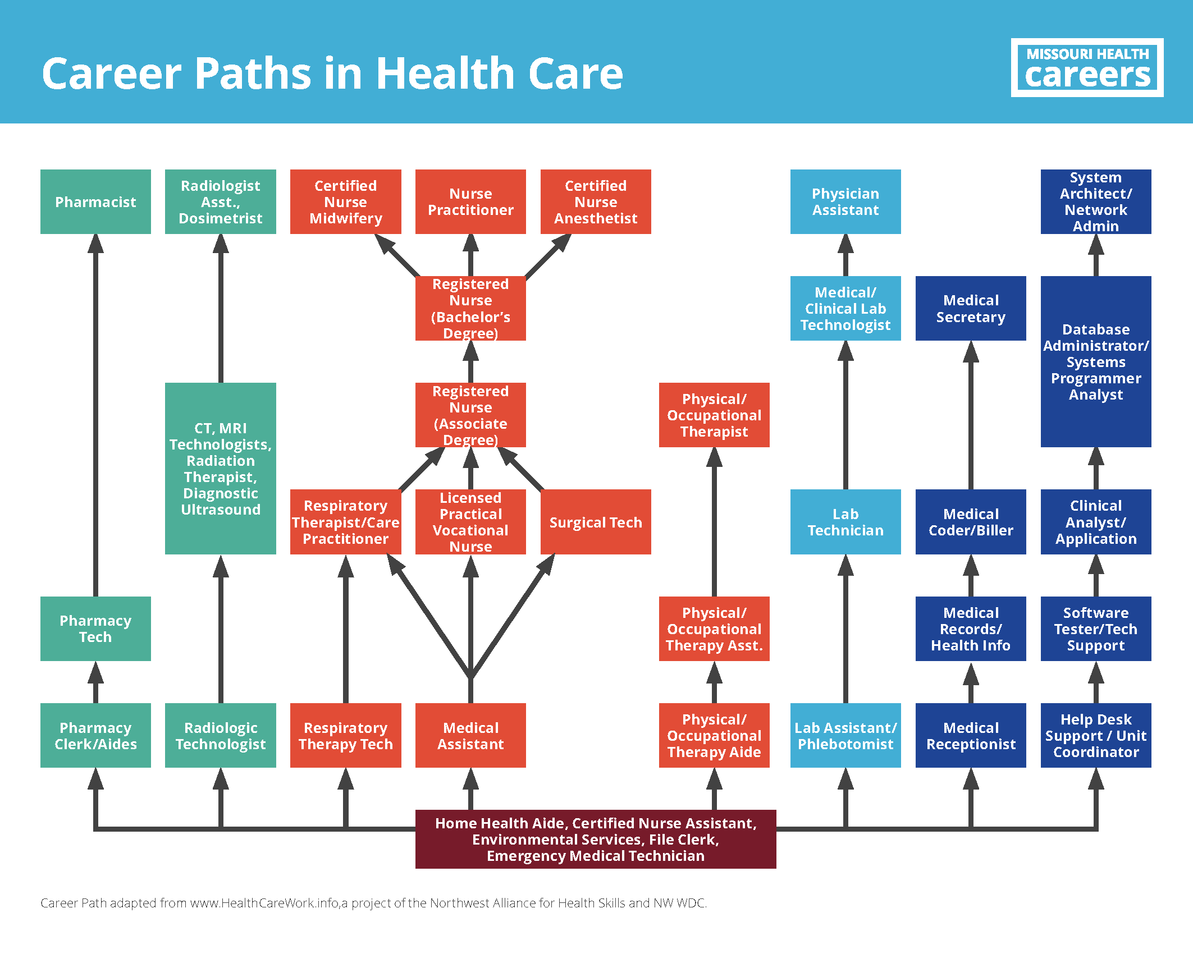

Apprenticeship Routes

What you need to know about NHS apprenticeships
- Any NHS employers will pay you more than the minimum wage
- If you are aged 16 to 18 or 19+ and in your first year of an apprenticeship, the minimum you should receive is £5.28 an hour (the National Minimum Wage for apprentices)
- Apprenticeships take between one and five years to complete
- Anyone over the age of 16 can do one
- Over a week, you're likely to spend the equivalent of four days on work placement and one day at a training centre or college
- You'll develop your skills, including English and maths
- You'll gain a competence qualification (based on what you can do in the workplace) and a knowledge qualification, or a qualification combining both
Examples of areas:
- Ambulance services
- Dental team
- Healthcare science
- Healthcare support work
- Midwifery
- Nursing
- Pharmacy
- Public Health

Examples of apprenticeships: NHS Jobs - Search Results (nhsj2.nhs.uk)
Jobs in Health and social care: Social care | Explore careers (nationalcareers.service.gov.uk)

